**“COSY AIR-CONDITIONERS”**

**“Mitsubishi”**

**“Models”**

**“Mitsubishi 1 Ton Inverter Series HJ35VA”**

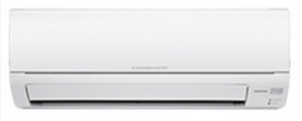

**Specifications**

**Cooling capacity ~** 1 Ton

**Cooling Type ~** Heat and Cool

**Technology ~** Inverter

**EER ~** 3.03

**Design Load ~** 1.5 - 3.1 kW

**RS ~ 81,000.**

**“Mitsubishi SRK 13CJK Heavy Industries”**

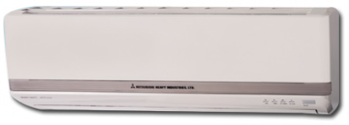

**Key Features**

* Wall mounted split air conditioner
* Tropical compressor (works upto 53 degrees)
* Copper condensor
* Auto restart
* LCD for temprature display
* Compressor type: rotary
* Made in Thailand
* **Specifications**
* **Cooling capacity**
* 1 Ton
* **Cooling Type**
* Cool Only
* **Technology**
* Conventional
* **Operating current**
* 4.5 - 5 A
* **maximum recommended area of cooling**
* 130 sq feets
* **Cooling gas**
* R22 (Chinese gas)

**RS ~ 48,000.**

**“Mitsubishi MS-13 VC 1 Ton Mr Slim Split”**

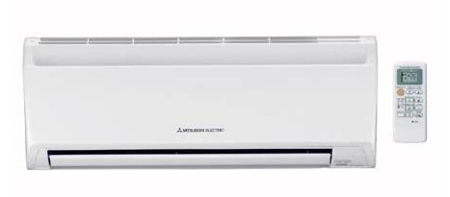

**FEATURES**

* Econo Cool
* New LEV Control
* Electronic Metal Housing Box
* Self-diagnostic Function
* Auto Restart Function
* Easy Clean
* Wide and Long Airflow
* Anti Rust Cabinet

**Specification**

**Cooling ~** 12000btu

**Power Input ~** 1220W

**EER ~** 9.7

**RS ~ 48,500.**

**“Mitsubishi MS-24 VC”**

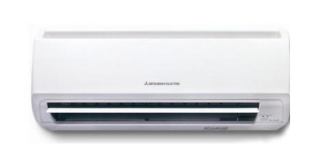

**FEATURES**

* Econo Cool
* New LEV Control
* Electronic Metal Housing Box
* Self-diagnostic Function
* Auto Restart Function
* Easy Clean
* Wide and Long Airflow
* Anti Rust Cabinet

**Specification**

**Cooling ~** 24000btu

**Power Input ~** 1220W

**EER ~** 9.5

**RS ~ 77,000.**

**“Mitsubishi Heavy Duty SRK25 CEVK”**

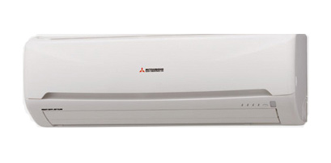

**FEATURES**

* 3D Auto air distribution by clicking once
* New LEV Control
* Electronic Metal Housing Box
* Self-diagnostic Function
* Auto Restart Function
* Easy Clean
* Wide and Long Airflow
* Anti Rust Cabinet

**Specification**

**Cooling ~** 24000btu

**RS ~ 80,000.**